Test Case: tc002_SPX_Dev5_Crear_Requisicion_Spot_Tipo_Cobro_Project
Step 1 - Enter username and password and click to button Enter: Credentials Entered
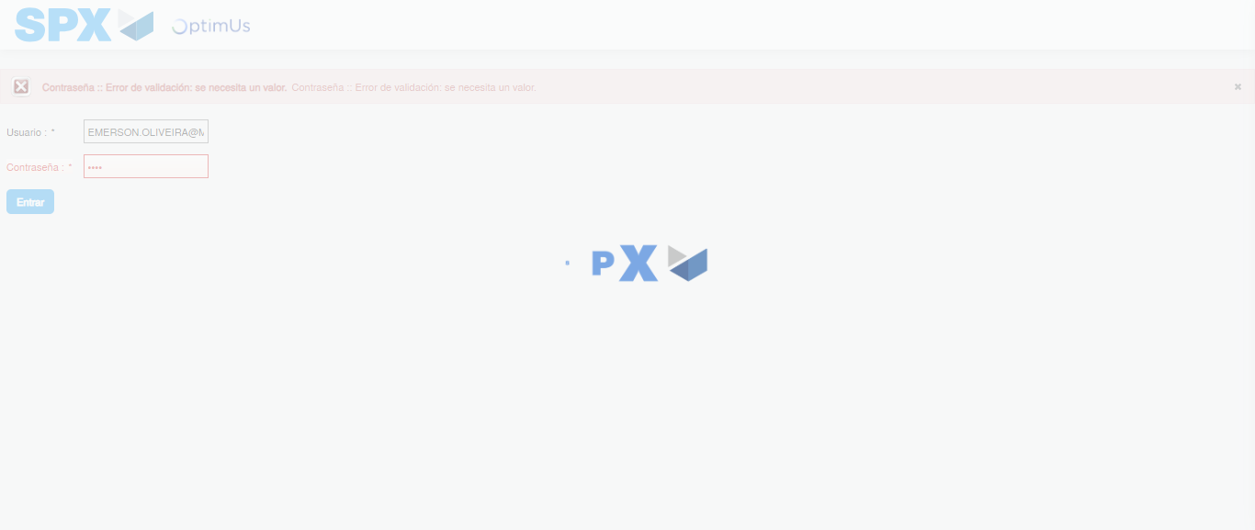Image file-name: QC_Testing-tc002_SPX_Dev5_Crear_Requisicion_Spot_Tipo_Cobro_Project-1785974917891

Step 2 - Select to UEN and Access to Spot Buy Requisitions : UEN Correctly selected and Correct access
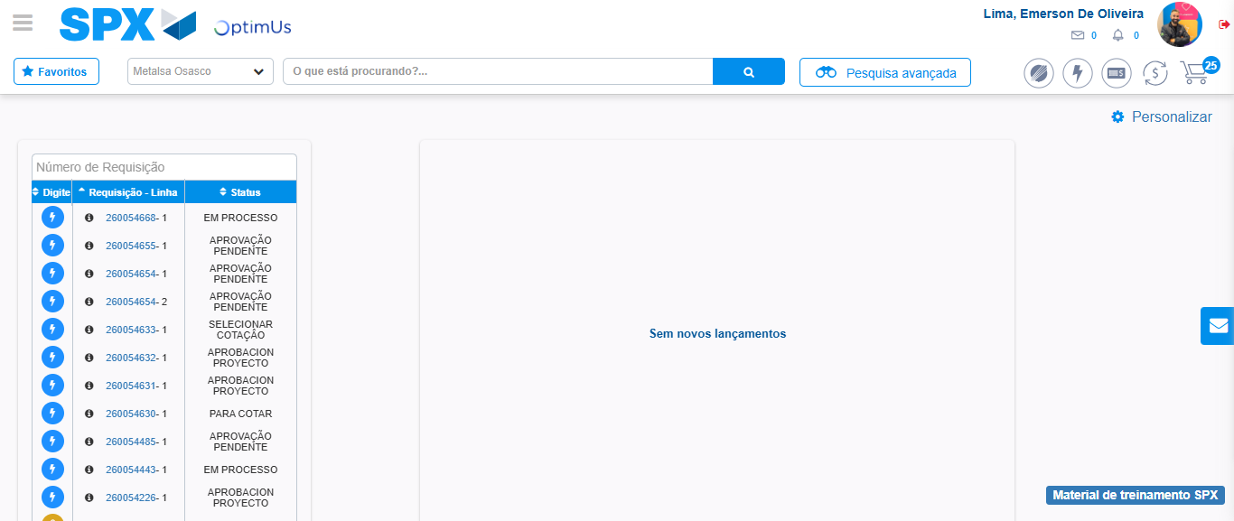Image file-name: QC_Testing-tc002_SPX_Dev5_Crear_Requisicion_Spot_Tipo_Cobro_Project-1785974942376

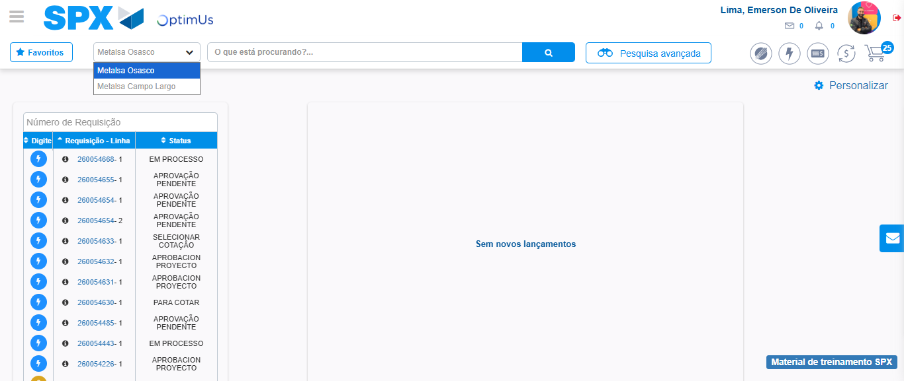Image file-name: QC_Testing-tc002_SPX_Dev5_Crear_Requisicion_Spot_Tipo_Cobro_Project-1785974944955

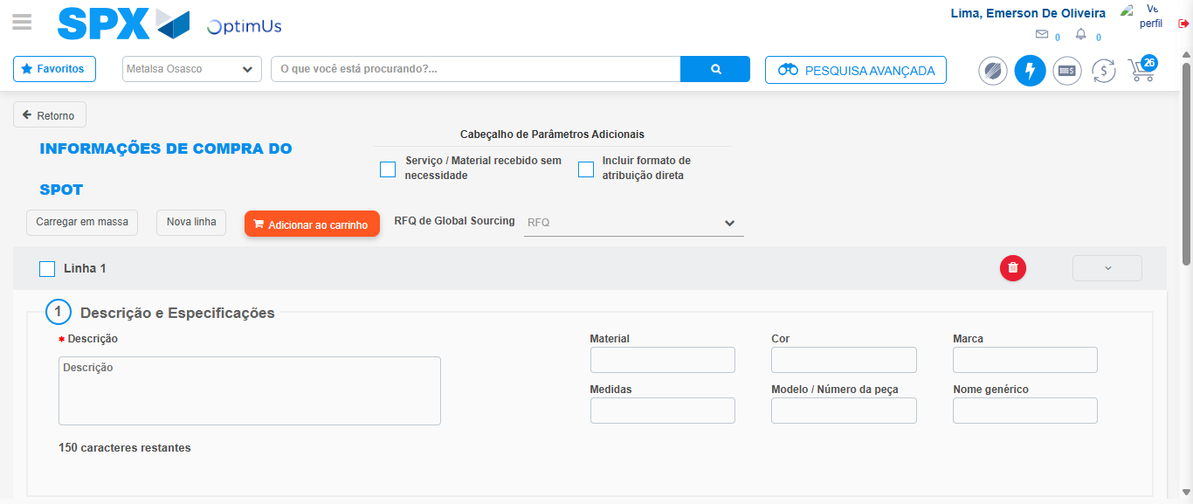Image file-name: QC_Testing-tc002_SPX_Dev5_Crear_Requisicion_Spot_Tipo_Cobro_Project-1785974949568

Step 3 - Data Capture Spot Buy Requisition: Data captured correctly
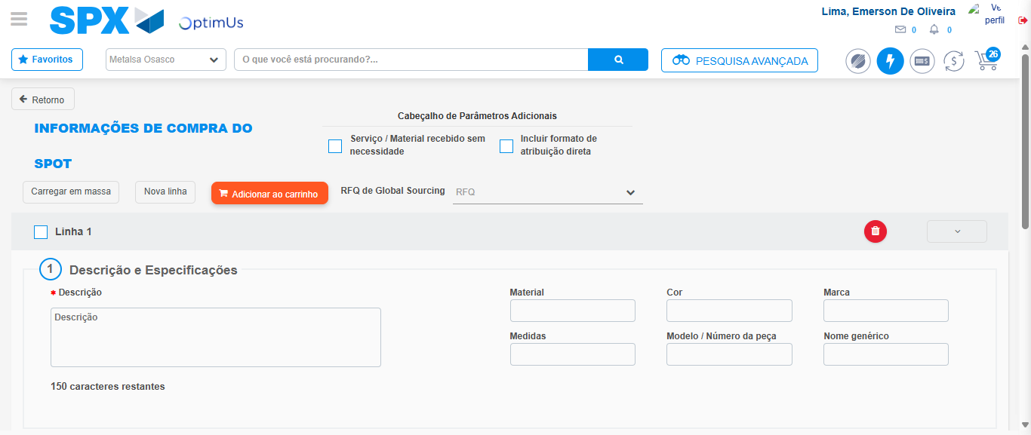Image file-name: QC_Testing-tc002_SPX_Dev5_Crear_Requisicion_Spot_Tipo_Cobro_Project-1785974949848

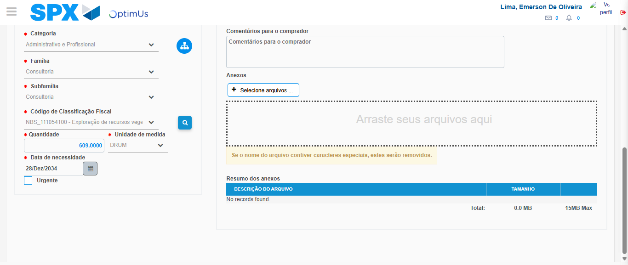Image file-name: QC_Testing-tc002_SPX_Dev5_Crear_Requisicion_Spot_Tipo_Cobro_Project-1785974966560

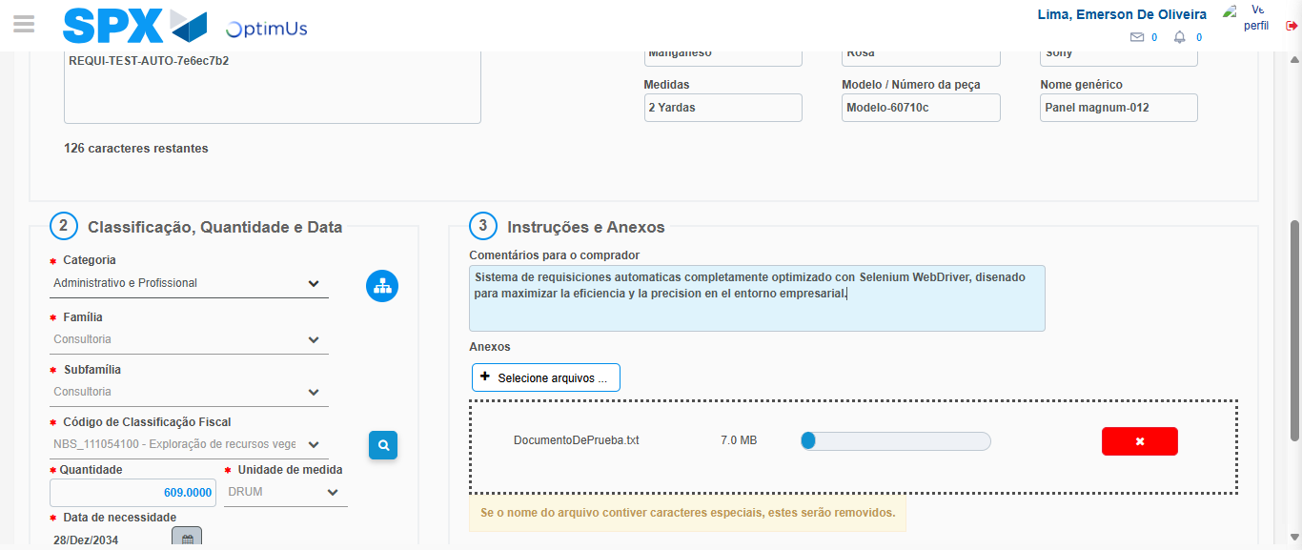Image file-name: QC_Testing-tc002_SPX_Dev5_Crear_Requisicion_Spot_Tipo_Cobro_Project-1785974967312

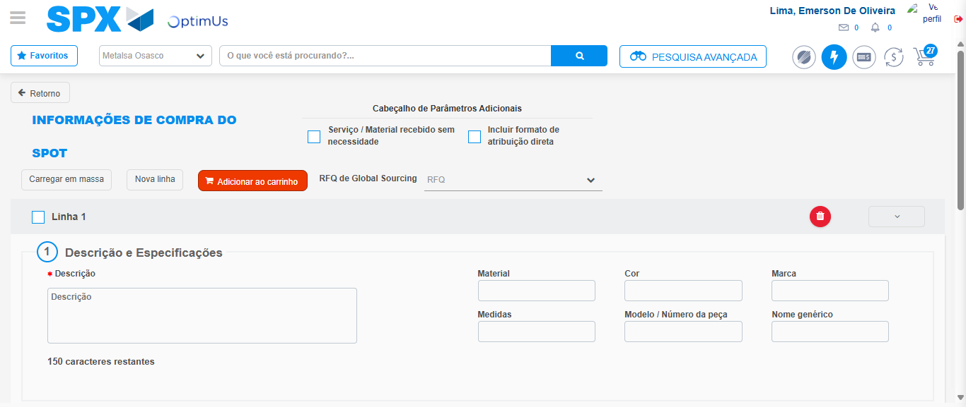Image file-name: QC_Testing-tc002_SPX_Dev5_Crear_Requisicion_Spot_Tipo_Cobro_Project-1785974971725

Step 7 - Return to Main Page SPX : Return to Main Page SPX
Image file-name: QC_Testing-tc002_SPX_Dev5_Crear_Requisicion_Spot_Tipo_Cobro_Project-1785974942376

Image file-name: QC_Testing-tc002_SPX_Dev5_Crear_Requisicion_Spot_Tipo_Cobro_Project-1785974944955

Image file-name: QC_Testing-tc002_SPX_Dev5_Crear_Requisicion_Spot_Tipo_Cobro_Project-1785974949568

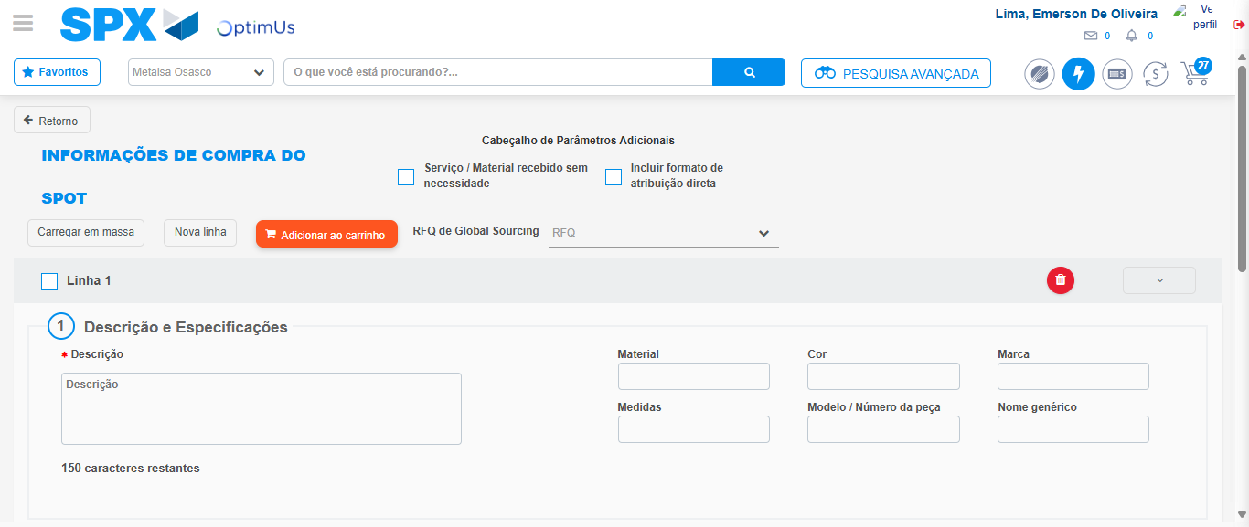Image file-name: QC_Testing-tc002_SPX_Dev5_Crear_Requisicion_Spot_Tipo_Cobro_Project-1785974974015

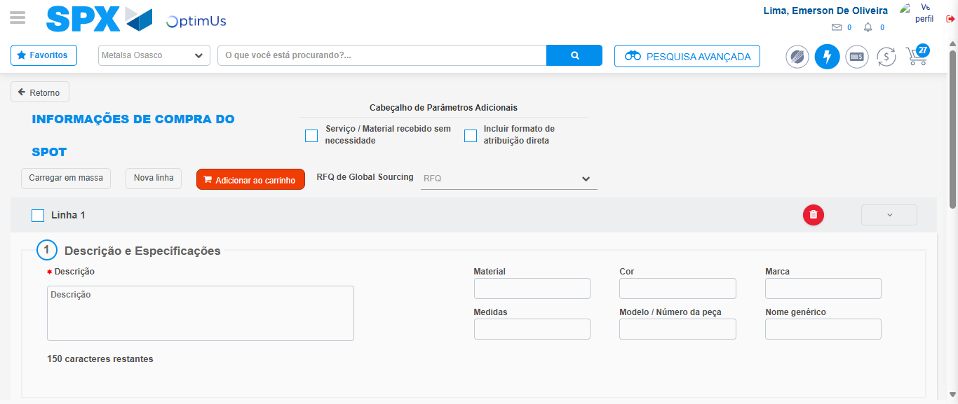Image file-name: QC_Testing-tc002_SPX_Dev5_Crear_Requisicion_Spot_Tipo_Cobro_Project-1785974974261

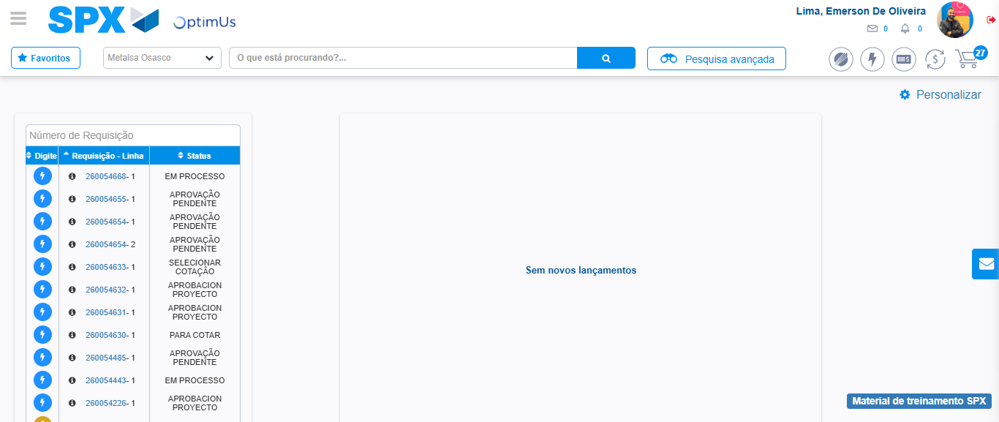Image file-name: QC_Testing-tc002_SPX_Dev5_Crear_Requisicion_Spot_Tipo_Cobro_Project-1785974995289

Step 8 - Log Out : Log Out SPX
Image file-name: QC_Testing-tc002_SPX_Dev5_Crear_Requisicion_Spot_Tipo_Cobro_Project-1785974995473

